Installation of FreeGLUT on Windows with VisualStudio 2022

**Download Visual Studio 2022**

1. Download Visual Studio 2022 and install Desktop Development with C++

**Download FreeGLUT**

1. Download the **freeglut 3.0.0 MSVC** Package file from: <https://www.transmissionzero.co.uk/software/freeglut-devel/>
2. Extract the contents of the freeglut-MSVC-3.0.0-2.zip file to a directory of your choice. For example, C:\freeglut

**Set Up FreeGLUT in Visual Studio 2022**

1. Open Visual Studio 2022.
2. Create a New Project:

* Click on Create a new project.

1. Select Project Type:

* In the search box, type console and select Console App under C++.
* Click Next.

1. Configure Your Project:

* Enter a Project name and choose a Location to save the project.
* Click Create.

1. Configure Project Settings:

* In the Create a new project dialog, ensure that Empty project is selected.
* Click Create.

1. Right-click on your project in the **Solution Explorer** and select **Properties**.
2. Configuration Properties > C/C++ > General, Find the **Additional Include Directories** field. Click on the field and then click <Edit...>, add the path to the include directory from the extracted FreeGLUT folder. (C:\path\to\freeglut-MSVC-3.0.0-2\include)
3. Go to Configuration Properties > Linker > General, Find the Additional Library Directories field. Click on the field and then click <Edit...>, add the path: C:\path\to\freeglut-MSVC-3.0.0-2\lib
4. Go to Configuration Properties > Linker > Input, Find the Additional Dependencies. In the Additional Dependencies field, click on the field and then click the <Edit...> button (or type directly):

freeglut.lib

opengl32.lib

glu32.lib

press ok.

1. Go to Configuration Properties> VC++ Directories, here find the Library directories. Click on the field and then click <Edit...>, add the path C:\Program Files (x86)\Windows Kits\10\Lib\10.0.22621.0\um\x64

Press ok and apply.

**Installation on Ubuntu:**

Now because GLUT (OpenGL Utility Toolkit) depends upon OpenGL and a number of other related libraries, if we install GLUT then OpenGL will be automatically be installed.

Run the following commands to install OpenGL.

**sudo apt-get update**

**sudo apt-get install libglu1-mesa-dev freeglut3-dev mesa-common-dev**

Test

#include <GL/freeglut.h>

// Function to display content

void display() {

glClear(GL_COLOR_BUFFER_BIT); // Clear the color buffer

// Set the drawing color to red

glColor3f(1.0f, 0.0f, 0.0f);

// Draw a rectangle

glBegin(GL_QUADS);

glVertex2f(-0.5f, -0.5f);

glVertex2f(0.5f, -0.5f);

glVertex2f(0.5f, 0.5f);

glVertex2f(-0.5f, 0.5f);

glEnd();

glFlush(); // Render now

}

int main(int argc, char** argv) {

// Initialize GLUT

glutInit(&argc, argv);

// Set the display mode

glutInitDisplayMode(GLUT_SINGLE | GLUT_RGB);

// Set the window size

glutInitWindowSize(500, 500);

// Set the window position

glutInitWindowPosition(100, 100);

// Create the window with a title

glutCreateWindow("Simple FreeGLUT Program");

// Set the background color to black

glClearColor(0.0f, 0.0f, 0.0f, 1.0f);

// Register the display callback function

glutDisplayFunc(display);

// Enter the GLUT event processing loop

glutMainLoop();

return 0;

}

Output:

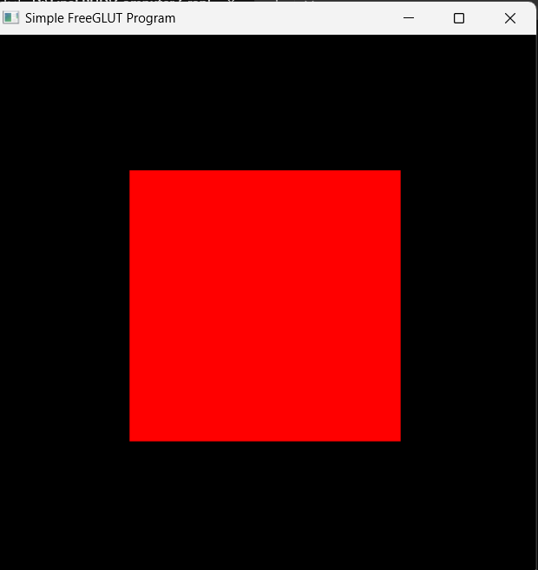

Now give the command below to compile your code in ubuntu.

**g++ main.cpp -o firstOpenGlApp -lglut -lGLU -lGL**

Now run your OpenGl program with following command

**./firstOpenGlApp**